DCN

Hotel Network Project

**Key Points**

* three routers connecting each floor
* All routers are connected to each other using serial DCE cable
* The network between the routers are 10.10.10.0/30, 10.10.10.4/30, 10.10.10.8/30
* Each floor has one switch (placed in the respective floor).
* Each floor has WIFI networks connected to laptops and phones.
* Each department has it’s own printer

**1st Floor**

**Reception-**VLAN 80, Network of 192.168.8.0/24

**Store-** VLAN 70, Network of 192.168.7.0/24

**Logistics-** VLAN 60, Network of 192.168.6.0/24

**2nd Floor**

**Finance-** VLAN 50, Network of 192.168.5.0/24

**HR-**VLAN 40, Network of 192.168.4.0/24

**Sales-** VLAN 30, Network of 192.168.3.0/24

**3rd Floor**

**Admin-** VLAN 20, Network of 192.168.2.0/24

**IT-**VLAN 10, Network of 192.168.1.0/24

* OSPF as the routing protocol to advertise routes.
* All devices in the network are to obtain IP address dynamically with their respective router configured as the DHCP server.
* All the devices in the network can communicate with each other.
* SSH in all the routers for remote login.

**Connect Three Routers For Each Floor and name them F1.Router, F2.Router, F3.Router Respectively**

**Connect 3 Switches and name them F1-Switch, F2-Switch & F3-Switch Respectively**

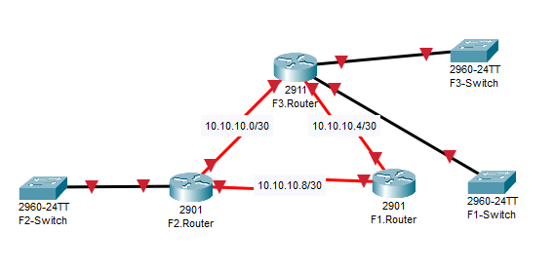

Connect Several Pc’s/Printers & Access-Points

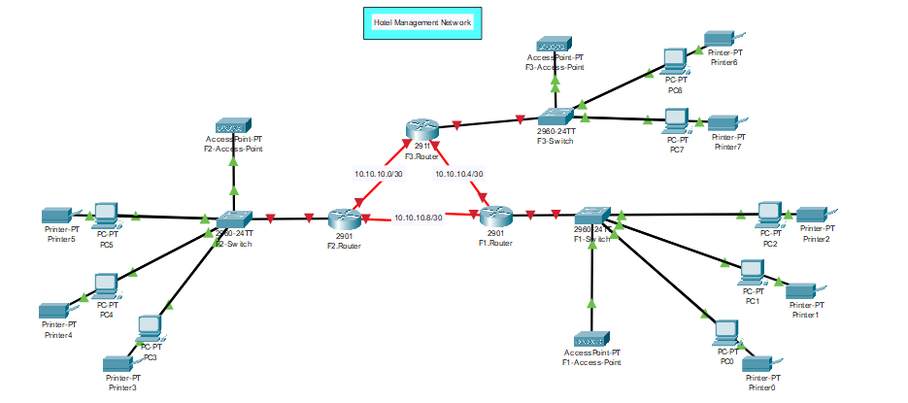

Draw borders to mark different floors and networks on each floor

**Configuration Of F1.Router**

**Configuration Of F2.Router**

**Configuration Of F3.Router**

**Configuration Of F1.Switch To Create VLAN 60, 70 & 80**

**Configuration Of F2.switch To Create VLAN 30, 40 & 50**

**Configuration Of F3.Switch To Create VLAN 10 & 20**  
  
**Configuration Of Routers To InterConnect**

F1.Router

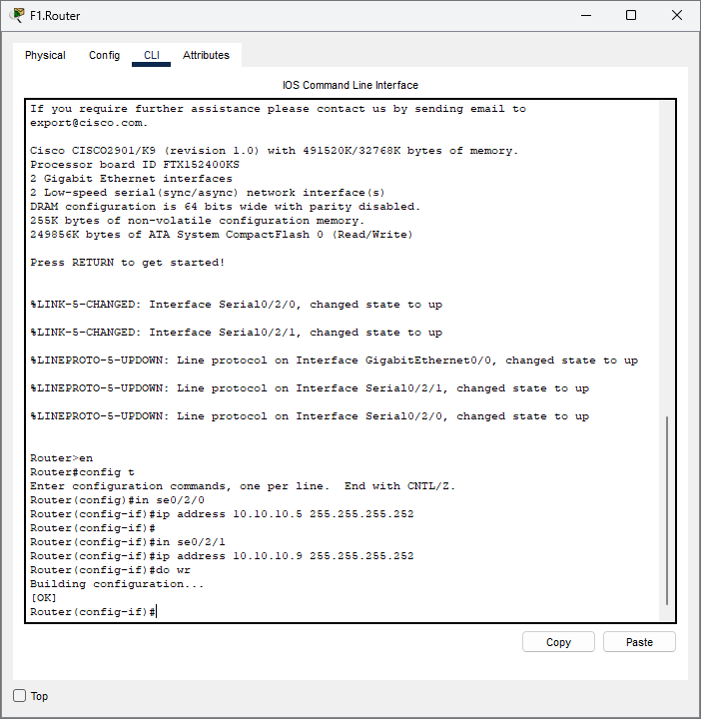

F2.Router

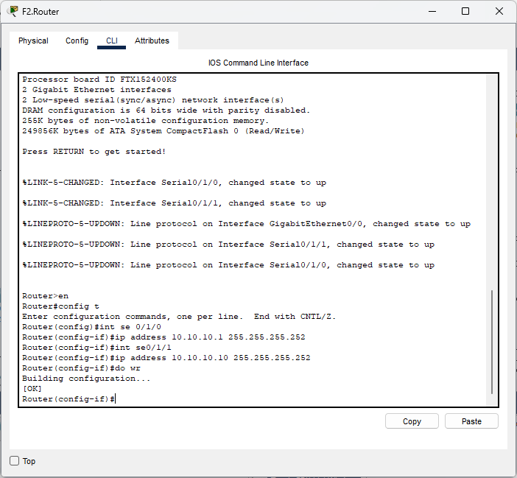

F3.Router

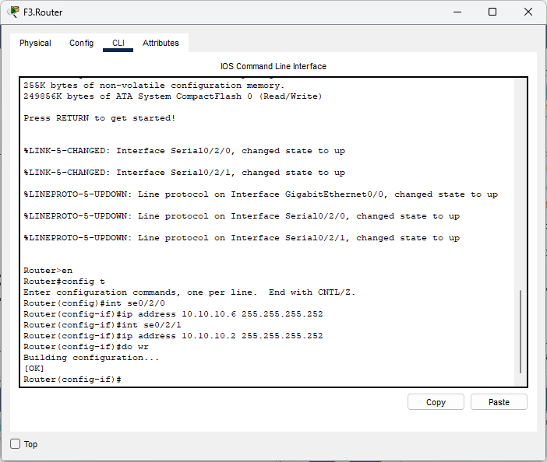

**Setting Up DHCP Protocol**

F1.Router

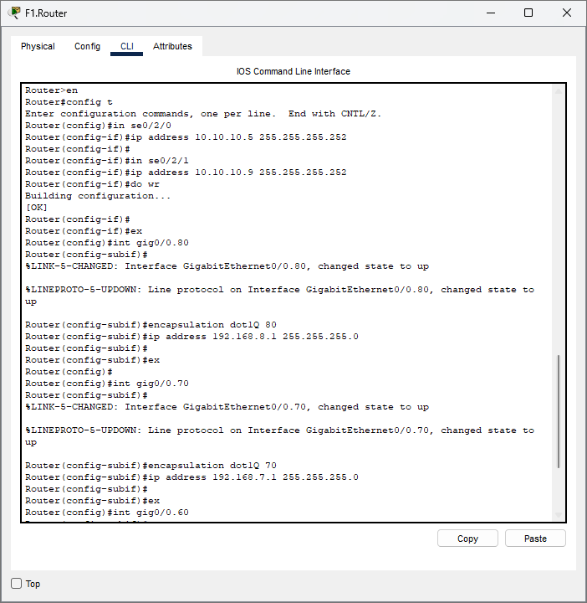

**Floor 1**

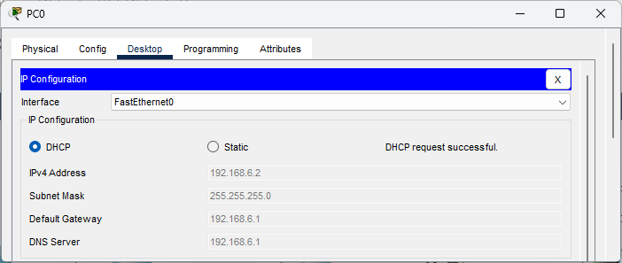

**PC1 🡪 PC2**

**Floor 2**

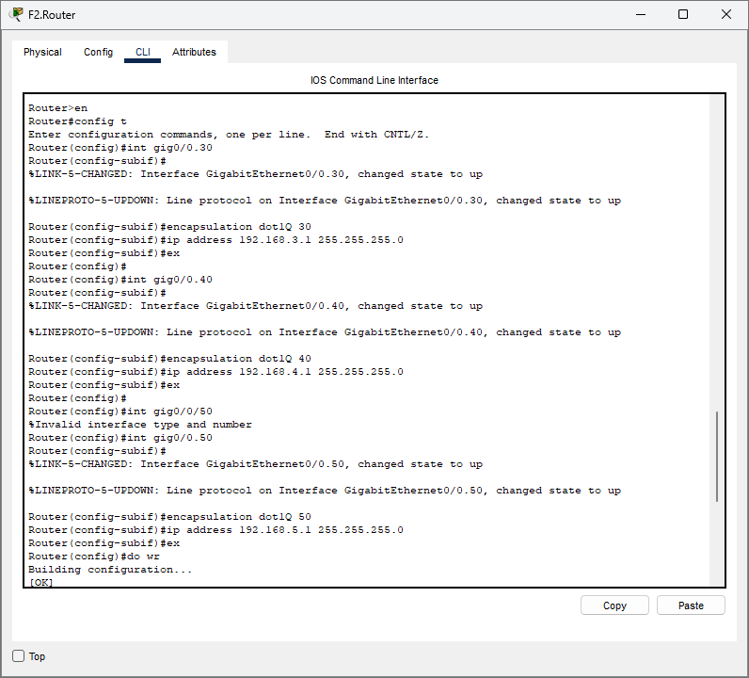

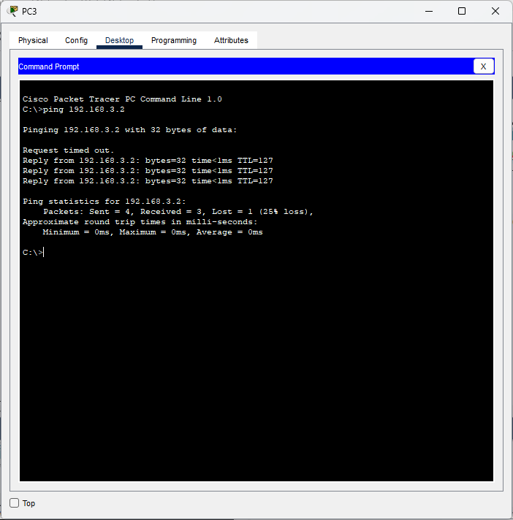**PC3 🡪 PC5**

**Floor 3**

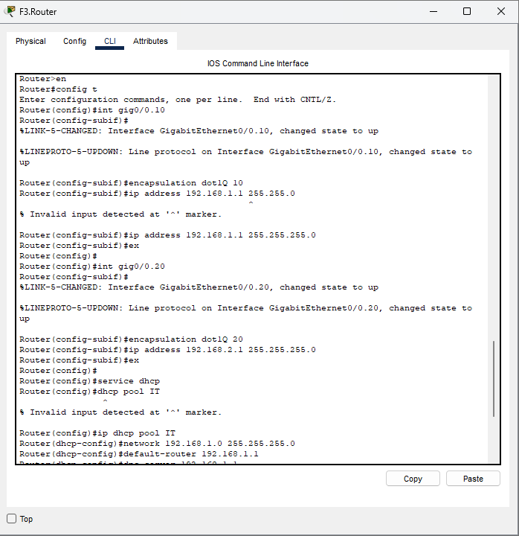

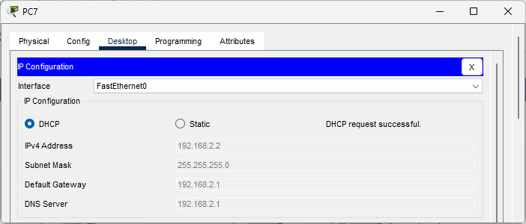

**PC 3 🡪 PC5**

**Can't communicate between different networks, but can communicate within the same network.**

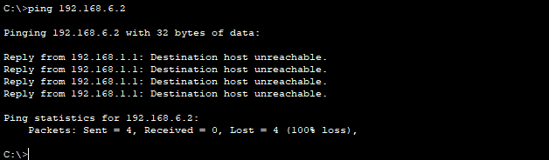

**OSPF CONFIGURATION**

**F1.Router**

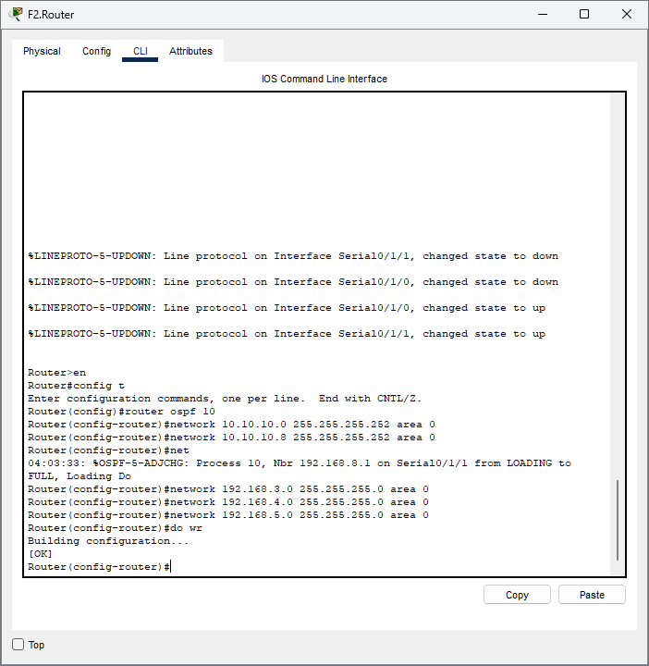**F2.Router**

**F3.Router**

**Pc 6 (F3) 🡪 Pc0(F1)**

**Pc 6 (F3) 🡪 Printer(F2)**

**SSH Configuration**

**F3.Router**

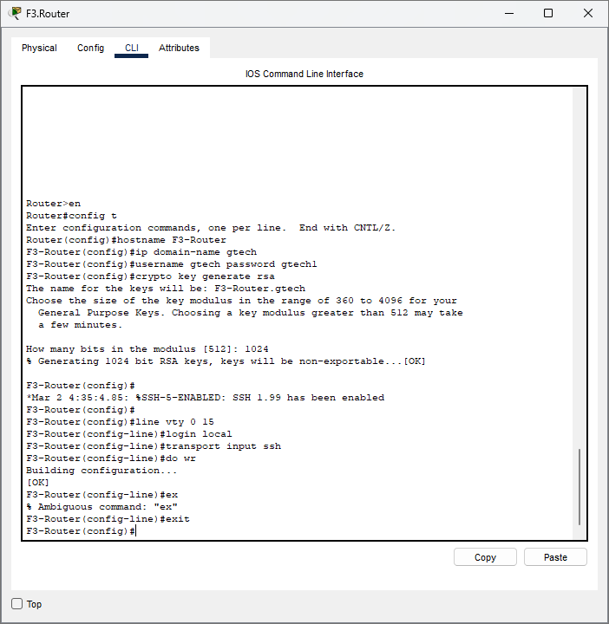

**F2.Router**

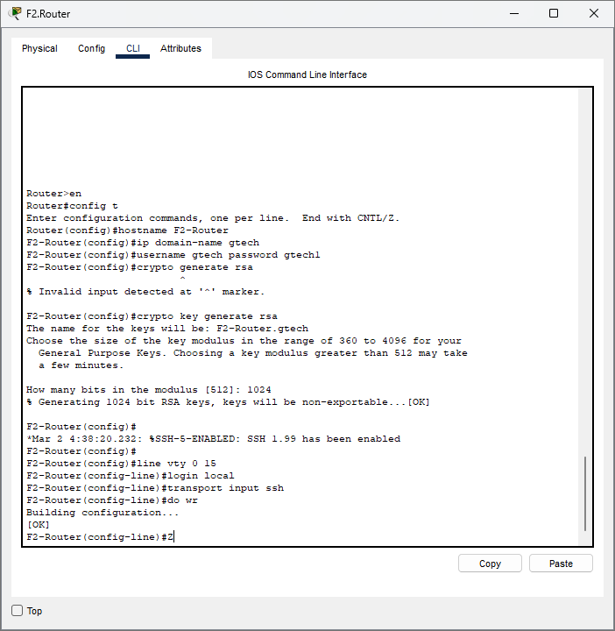

**F1.Router**

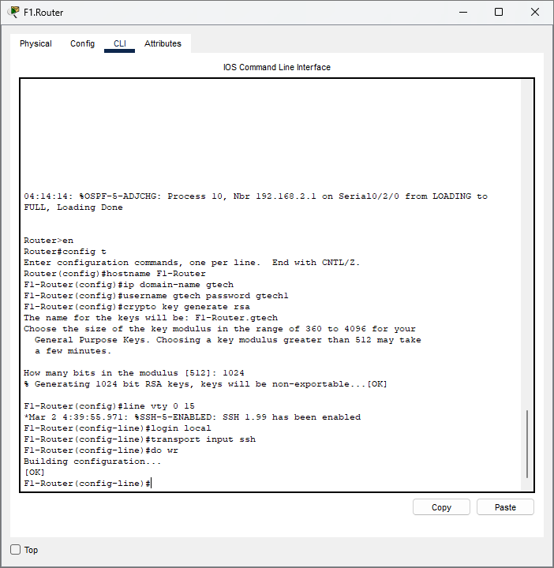

**Rename pc6 to test pc to test remote login**

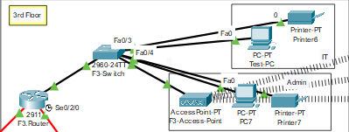

**Configuring Port-Security (Test – PC)**

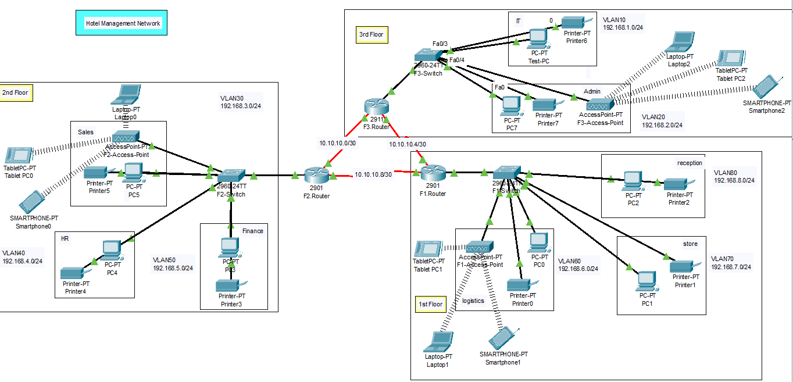**HOTEL NETWORK**